**BABY SNUGGLE WRAP**

**Pattern by Sally Dopson: This pattern may be freely used for charitable purposes only.**

**No commercial or personal sales of pattern or garment is allowed.**

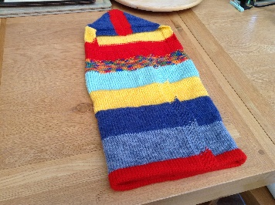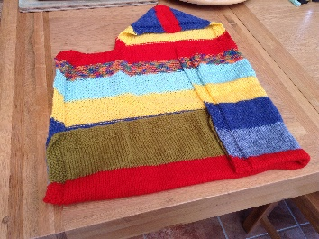

|  |  |  |
| --- | --- | --- |
|  | Abbreviations | |
| DK Yarn  Finished weight of garment is 200grms  4mm needles | K  P  MS  WS  RS  St(s)  SS | Knit  Purl  Moss St  Wrong side  Right side  Stitch(es)  Stocking stitch |

Cast on 120 sts

Row 1 K1P1 rep. to end

Row 2 P1K1 rep. to end

Repeat row 1&2 10 times more (12 rows in total) Moss Stitch (MS)

Row 13 (K1P1) 3 times K to last 6 sts (K1P1) 3 times

Row 14 (P1K1) 3 times P to last 6 sts (P1K1) 3 times

Repeat row 13 & 14 until work measures approx. 20 ins. In length ending with WS row

Next row (RS) (K1P1) 17 times K52 (K1P1) 17 times K1

Next row (WS) K1 (P1K1) 17 times P52 (K1P1) 16 times K1

Repeat these last two rows 5 times more (12 rows in total for MS shoulder)

Cast off 28 sts. (K1P1) 3 times. K50 sts (P1K1) 3 times. Cast off 28 sts.

Hood

Rejoin yarn and continue in the same pattern of 6 MS Border at each end of row, SS in between. Continue until hood panel measures approx. 8½ins.

Slip 31 sts onto another needle

(preferably a DPN otherwise you will have to slip sts a second time to get your needle points matching up when you fold the panel to close the hood seam)

Close hood seam with either the three needle cast off or the Kitchener Stitch.

Sew in loose ends.

Do not stitch a turn=up into place but leave the garment as a ‘square’ with a hood. This gives flexibility for use on a variety of sizes of babies.